Mock Interview Practice Instructions

Description: Interviewing is a pivotal part of the process of pursuing a new position, yet it is the most intimidating for some. This activity utilizes Big Interview, a platform that provides an opportunity to engage in a general or tailored mock interview. Moreover, the platform allows you to rate yourself and also view examples of responses for different question type.

Objective: Students will be able to engage in a tailored, mock interview to enhance their interviewing skills.

Materials Needed: Computer or laptop with a webcam
Instructions:

- Go to uga.biginterview.com
- Click “Register” and use your UGA email to create a free account

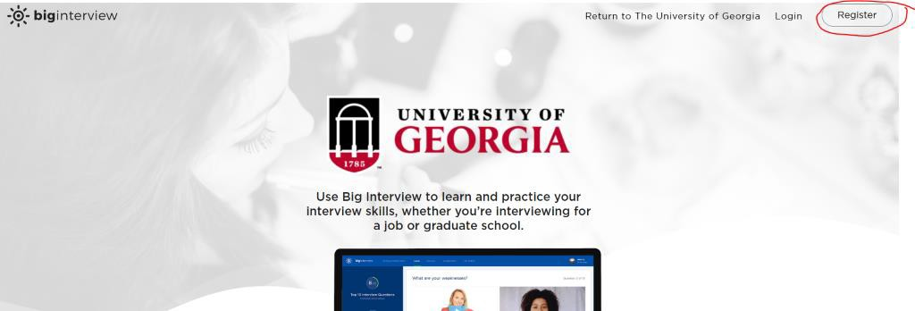

Two Options for the Practice Interview

- Option 1: Click here to complete a mock interview assignment on the Big Interview platform. Use the assignment code: c37f13.

- Option 2: Click “Practice” which will produce a drop down menu; then click “Practice Interviews”

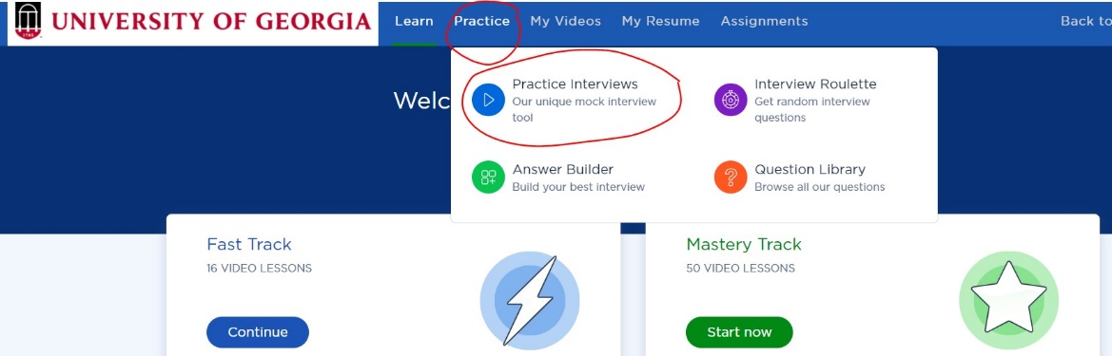

  - Click “Custom Sets”

- Select a practice interview for your career path. For example, if you’re planning to transition to a career in the government, select that option.

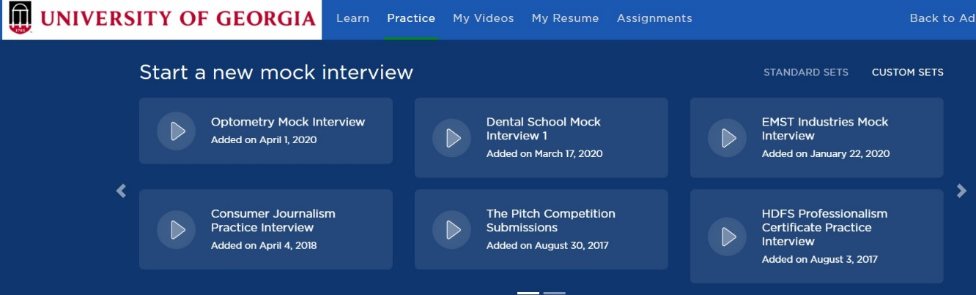

- Now you’ll record your answers to each question! At the end, you can rate yourself on a variety of skills. You can also visit the “Learn” tab to learn more about strategy and how to best answer common questions. The “My Videos” tab contains all of your recorded practice interviews for future reference.

